**34)**

**Aim:** To Draw a Deterministic Finite Automata that accepts a language L over input alphabets ∑ = {0, 1} such that L is the set of all strings starting with ’00’.

**Diagram:**

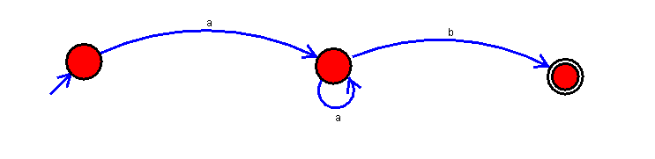

**Result:**

Thus, successfully executed Deterministic Finite Automata that accepts a language L over input alphabets ∑ = {0, 1} such that L is the set of all strings starting with ’00’.